Overview

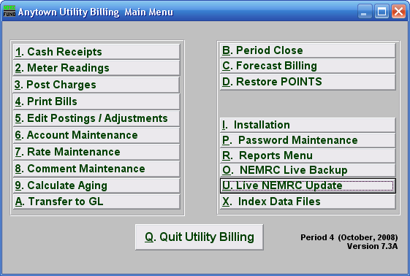

NEMRC Utility Billing is a flexible billing and receivables system that can be linked to your NEMRC General Ledger. All billing rates are defined by the user. An unlimited number of rates and meters may be attached to any single account. Bills and statements may be produced by individual service or by all services provided (maximum 4). Accounts may also be grouped by book number to allow processing of a limited number of accounts at any one time. Information tracking and reporting is based on transaction dates and due dates.

Utility Billing records include both active (current) and inactive (history) data. Accounts that have been paid are moved to history when the period is closed.

